Lab2 Report

Q1: Our strategy is to pre-assign a specific capacity for the job-queue, once the queue reaches its maximum, we suspend to receive new request before the old ones have been solved. In this method we can prevent the following two scenarios occur.

S1: A writer is always pending for the previous readers/writers to finish

S2: A reader is always pending for the previous writers /readers to finish

Q2: We implemented the strategy as suggested in the question and depicted the result with excel.

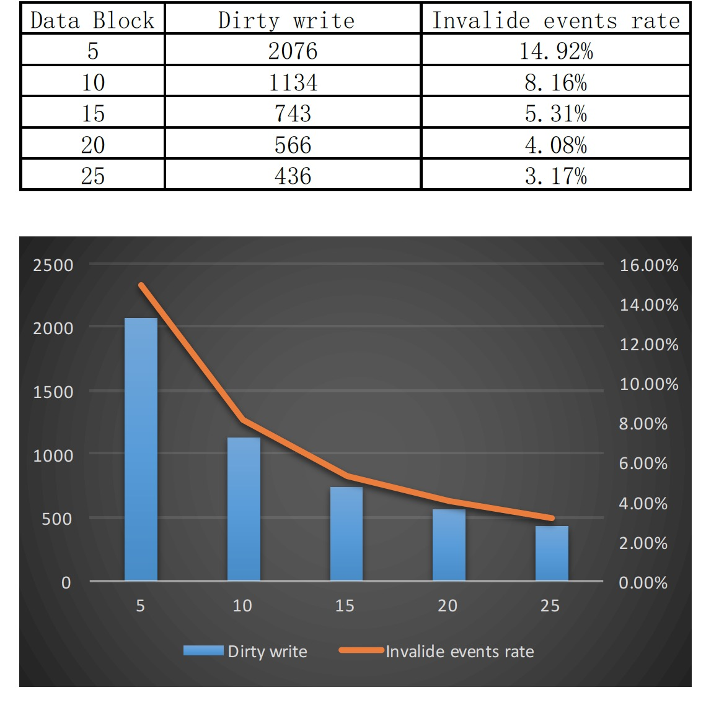

We can figure out that the more data block we assigned，the less chance invalid dirty write will occurred. Because with fixed operations, if we have more data blocks in database, then the probability of two request target on the same block will be extremely small. And the threshold of achieving an invalided events rate under 5.00% is lying between 15-20 blocks.